**What is Livera**

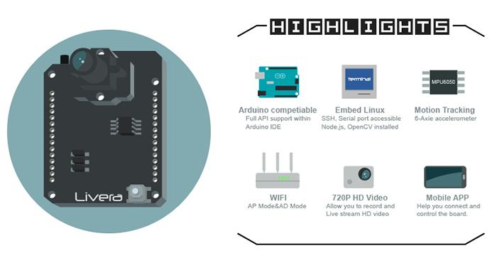

Welcome to start the new adventure with Hicat!! Happy hacks. :p

In a nutshell, Livera by Team HiCat is an open source hardware project which aims to bring machine vision features to the Arduino community. It is also a good platform for building visual driven robotics.

We've provided libraries which contain machine vision related APIs such as:

* 720hd video and photo capturing&processing
* OpenCV enabled Color-Sensitive and Object-Tracking.
* Wifi enabled wireless control (this can work with the iot!)
* Image capturing and data recording onto the onboard sd card
* Mobile observation and manipulation from our custom apps( web-based and native)
* Programmable and open source.

**what Livera could do:**

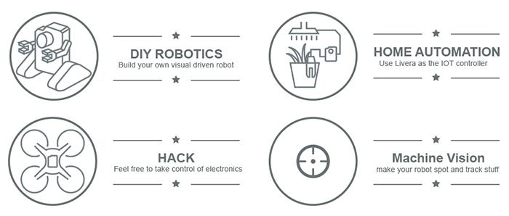

<http://hicat.tech/Livera-Documentation/>